Node module folder contains all third party module on which our application might depend on.

While production we exclude this folder. This is only required for development purpose.

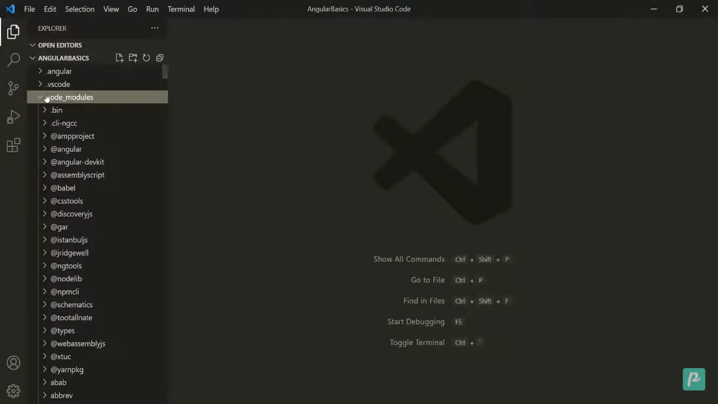  
Below this we have source folder

Which contain all our source program

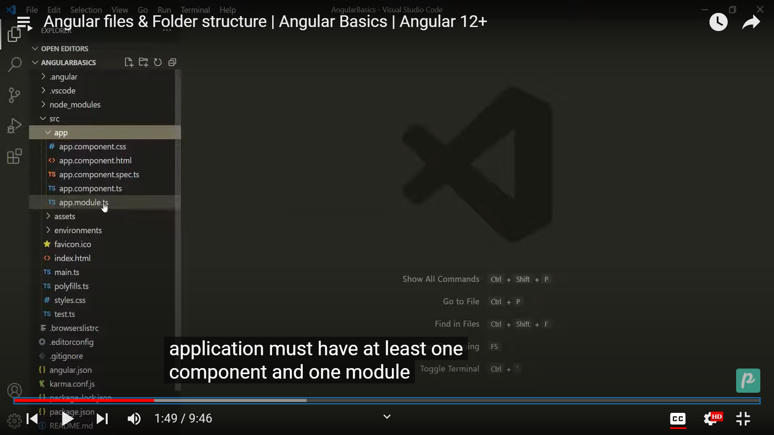

New Component will be ceate in app component onl.Below that we have asset which contain image,icon text file and etc.

Then we have environment to set up different environment. In this we have two files one for production and another for development.

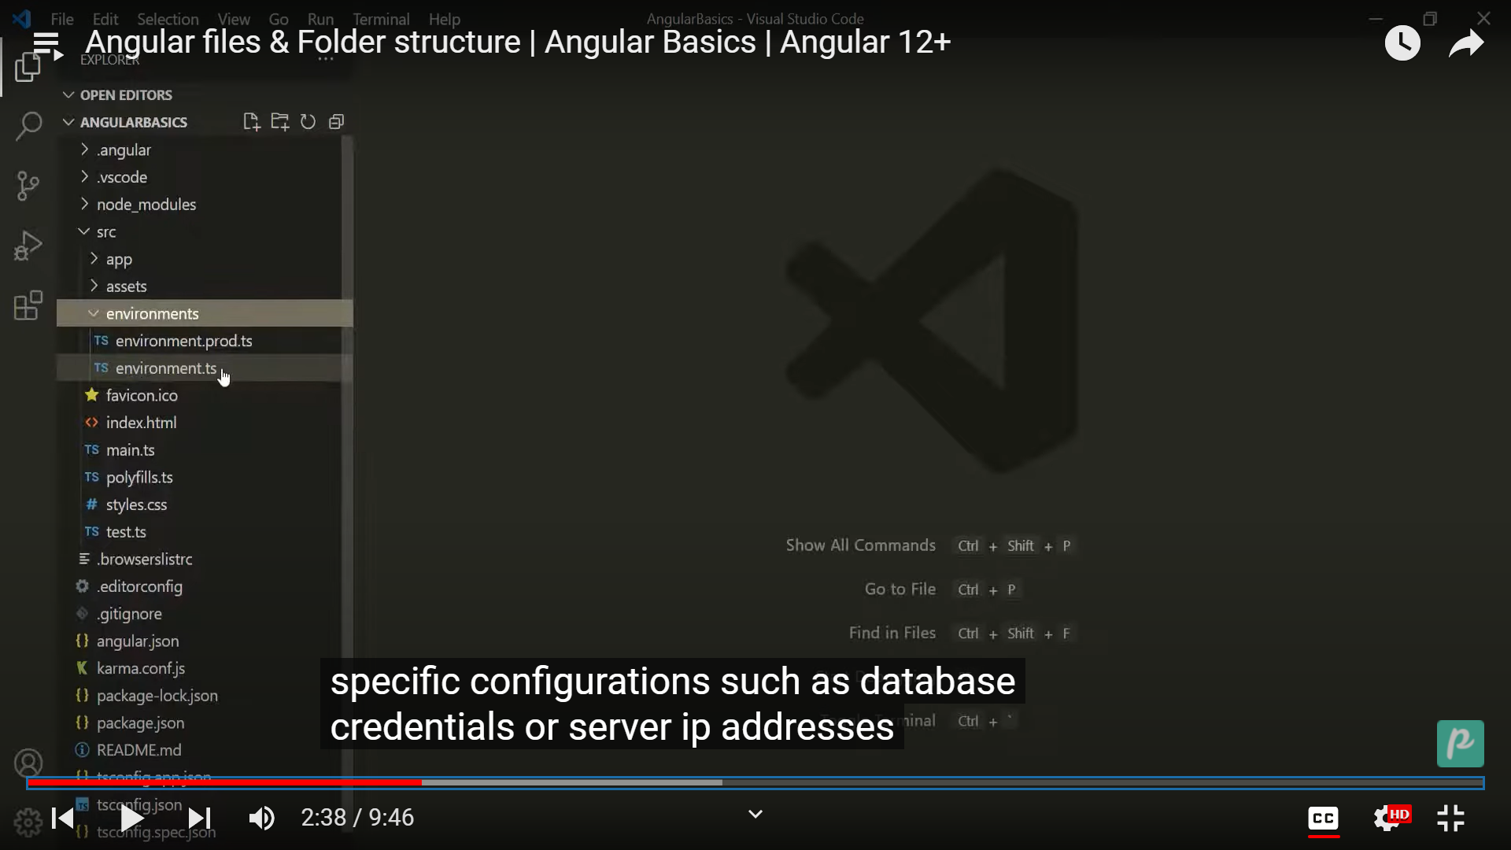

Then we have favicon : it is the icon file display on the browser. Then main index.html file

Then we have main.ts file : This is typescript file which is starting point of application.

Then we have polyfills.file: It import script which are required for running the angular.

Style.css: Globally style sheet can be added.

Test.ts: for testing the setting environment

Editor.coonfig: It is used to set up team environment.

Angular.json: It contain all the configuration of Jason.

Karma.config.js: for test runner

Package.json:It contain all dependencies and configuration

Tsconfig:configuration for typescript compiler compile typescript into javascript.

TypeScript:

